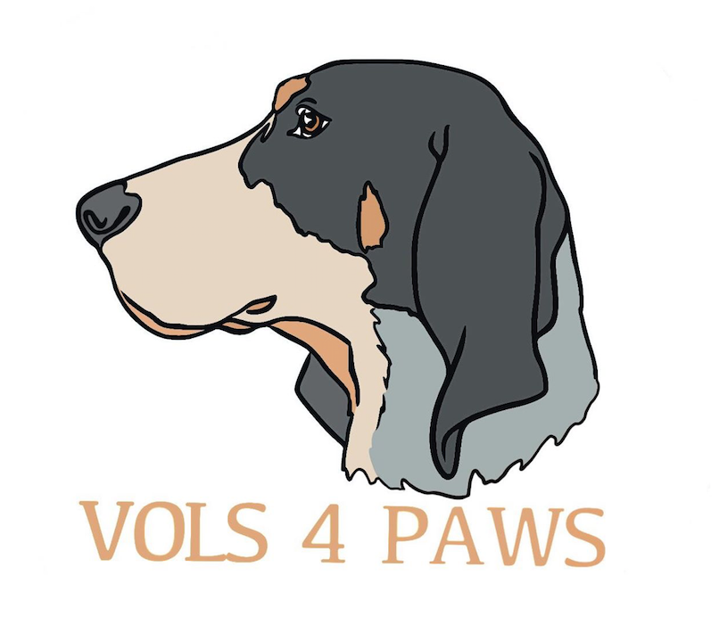

Adoption Contract

Dog ____ Cat ____ Male/Female Age:__________ Description: _________

Color:__________ Name: _________________ Adoption Date: ______________

Name:___________________________________________________ Driver license # :_____________________
Address:__________________________________________________________________________________________
City:_____________________________ State: ___________________ Zip Code:____________________________
Home Phone:_____________________ Work:_______________________ Cell:___________________________
Email:______________________________Employer:____________________________________________________

I agree that in consideration of being allowed to adopt the above animal from Vols 4 Paws Rescue, I will fulfill the following contractual requirements. If I am unable or unwilling to do so, I must return the pet to Vols 4 Paws Rescue or I agree that the animal may be impounded from me.
INITIAL (each agreement below)
___________1. I agree to pay the full adoption fee of ___________.
___________2. I agree to provide the animal proper food, shelter, water, veterinary care, and loving humane treatment at all times. I further agree to keep a collar and current rabies tag on this pet at all times. If I do not abide by this provision I may be asked to forfeit ownership of this animal.
___________3. If at any time I am no longer able for any reason to care for this pet, I agree to return it to Vols 4 Paws Rescue. I further agree not to abandon, give away, or sell this animal.
___________4. By signing this Agreement, I hereby affirm that I have not been convicted of any act of animal cruelty in any court of competent jurisdiction within the past ten years.
___________5. I understand that there is no warranty, express or implied, by the V4P of this animal’s age, breed, health, future size, behavior or temperament. I hereby release and agree to hold harmless the V4P, its employees, agents, directors, members, successors and assigns from any claim, suit, demand, liability, or cause of action arising out of, or in any way related to my adoption or ownership of this pet.
___________6. Attorney fees & court costs: I agree to pay reasonable attorney’s fees and court costs in the event this matter requires the services of an attorney for Vols 4 Paws Rescue to enforce the terms and conditions of this contract.
___________7. I agree to allow a V4P agent to visit this pet, at any reasonable time, to verify that it is being provided humane care.
I HEREBY CERTIFY THAT THE INFORMATION GIVEN TO VOLS 4 PAWS RESCUE IN MY APPLICATION IS TRUTHFUL AND ACCURATE. IF I BREACH ANY OF THE TERMS AND CONDITIONS OF THIS AGREEMENT, I AGREE THAT V4P MAY REPOSSESS THIS ANIMAL. I HAVE READ ALL OF THE ABOVE AND AGREE TO BE LEGALLY BOUND TO THE TERMS AND CONDITIONS STATED.

Signature: _____________________________________________________________ Date: ________________________________

